**EXPERIMENT NO. 5**

**TITLE :**To demonstrate various DOS commands.

**OBJECTIVE :**

* To learn about command prompt.
* To learn various commands of dos.

**THEORY :**

A DOS, or disk operating system, is an operating system that runs from a disk drive. The term can also refer to a particular family of disk operating systems, most commonly [MS-DOS](https://www.techtarget.com/searchenterprisedesktop/definition/MS-DOS), an acronym for Microsoft DOS

An operating system (OS) is the software that controls a computer's hardware and peripheral devices and allows other software programs to function. Early computers of the 1940s and 1950s did not have disk drives. Instead, they were hard-wired to carry out specific computations.

**DEMONSTRATION :**

* 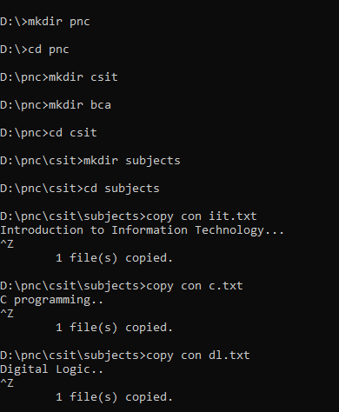Creating directories and files.

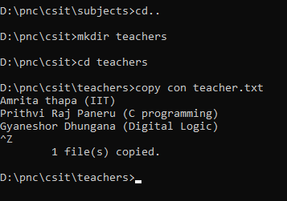

* 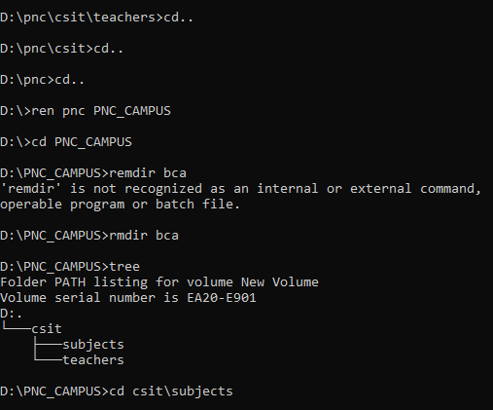Renaming and removing the directories.

**CONCLUSION :**

This laboratory exercise provided a hands-on experience in various DOS command. Creating new directories and files using ms-dos and editing them with commands. After completing the lab experiment, students gained the practical knowledge of the ms-dos.